Huskie 2.0

Assembly Instructions

Version 3, 4/26/2016

|  |  |  |  |
| --- | --- | --- | --- |
| Assembly Instructions  Version | Date | Changed by | Reason for change |
| 1 | 2/8/2016 | D. Emge | Original, prototype build |
| 2 | x | x | Intentionally skipped to sync assy and BOM versions |
| 3 | 4/26/2016 | D. Emge | Fix power supply oscillation, pilot build.  Add section 5, rework instructions for converting from version1 to version 3. |

1. General Information
   1. This is a lead-free assembly.
2. Surface Mount Assembly

Please reference Figure 1.

* 1. The following parts are not installed:
* C14, C15, C17
  1. LEDs D1 through D4 are installed with Anodes at the bottom and Cathodes at the top. Cathodes are marked with a silkscreen dot.
  2. LEDs D5 through D7 are installed with Anodes on the right and Cathodes on the left.

Cathodes are marked with a silkscreen dot.

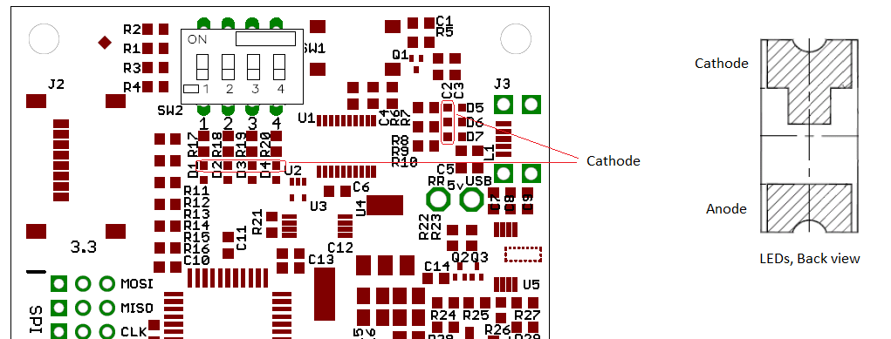

Figure , SW2 and LED Orientation

1. PTH Assembly – Primary Side
   1. SW2 is installed with the orientation shown in Figure 1, above, with the switch numbering aligned with the board’s silkscreen number markings.
   2. Header pins are arranged in sets of 3. Pins must be parallel in final assembly to allow proper connection of individual 3-pin mating connectors (each square pin is pin 1 of a 3-pin connection). Use a jig if necessary to maintain parallelism.

There are qyt 3 36-pin header strips on the BOM. They are separated into smaller headers as follows for installation on the PCB.

* + 1. Header strip 1: Separate into qty 3 12-pin strips and install in Location

A

* + 1. Header strip 2:
* Separate into qty 3 10-pin headers and install in Location

B

* Separate the remainder into qty 2 3-pin headers and install in location

C

* + 1. Header strip 3:
* Separate into qty 3 7-pin headers and install in Location

D

* Separate from the remainder qty 3 4-pin headers and install in Location

E

* Install the remaining 1x3 pin header into Location

F

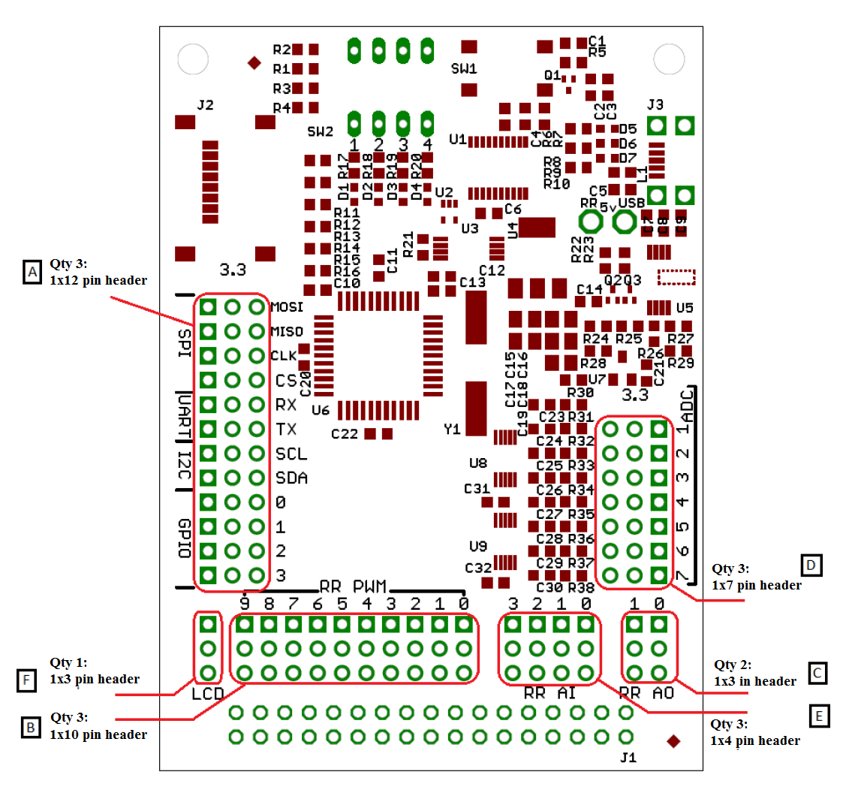

Figure , Header Placement

1. PTH Assembly – Secondary Side

J1 is installed on the secondary with the key oriented as shown below. It must be installed perpendicular to and flush with the PCB.



1. Rework Instructions, Version 1 to Version 3

For new builds, ignore this section.

* 1. Remove capacitors C15 and C17.
  2. Remove U4 and replace with device indicated on BOM version 3.